
Department of Computer Science & Engineering

Program: Bachelor of Engineering in Computer Science & Engineering

A Project Report on
Cognitive Psychology Approach to Analyse Information in Social Network Using MachineLearning
Submitted in partial fulfillment of the requirements for the course

CSP67: MINI PROJECT

By

Aryan Kumar 1MS22CS035
Basavaraj Bhjantri 1MS22CS041
Hariprasad B R 1MS22CS057
I Suprabath Reddy 1MS22CS065

Under the guidance of

Akshata S. Bhayyar

Assistant Professor

M S RAMAIAH INSTITUTE OF TECHNOLOGY
(Autonomous Institute, Affiliated to VTU)
BANGALORE-560054
www.msrit.edu
2025
M. S. RAMAIAH INSTITUTE OF TECHNOLOGY, BANGALORE – 560 054
(Autonomous Institute, Affiliated to VTU)

DEPARTMENT OF COMPUTER SCIENCE AND ENGINEERING



CERTIFICATE

Certified that the project work titled carried out by 1MS22CS035 Aryan Kumar, 1MS22CS041 Basavaraj Bhjantri, 1MS22CS057 Hariprasad B R, 1MS22CS065 I Suprabath Reddy are bonafide students of M. S. Ramaiah Institute of Technology, Bengaluru, in partial fulfillment of the course Mini Project CSP67 during the term March-June 2025. The project report has been approved as it satisfies the academic requirements for the aforesaid course. To the best of our understanding, the work submitted in this report is the original work of students.

Project Guide Head of the Department

Akshata S. Bhayyar Dr R China Appala Naidu External Examiners

Name of the Examiners: Signature with Date

1.
2.
DECLARATION

We, hereby, declare that the entire work embodied in this mini project report has been carried out by us at M. S. Ramaiah Institute of Technology, Bengaluru, under the supervision of Akshata S. Bhayyar Assistant Professor in Department of CSE. This report has not been submitted in part or full for the award of any diploma or degree of this or to any other university.

Signature Signature
Aryan Kumar Basavaraj Bhajantri
1MS22CS035 1MS22CS041

Signature Signature
Hariprasad B R I Suprabath Reddy
1MS22CS057 1MS22CS065

ACKNOWLEDGEMENT

We take this opportunity to express our gratitude to the people who have been instrumental in the successful completion of this project. We would like to express our profound gratitude to the Management and Dr. N.V.R Naidu Principal, M.S.R.I.T, Bengaluru for providing us with the opportunity to explore our potential.

We extend our heartfelt gratitude to our beloved Dr R China Appala Naidu, HOD, Computer Science and Engineering, for constant support and guidance.

We whole-heartedly thank our project guide Akshata S. Bhayyar for providing us with the confidence and strength to overcome every obstacle at each step of the project and inspiring us to the best of our potential. We also thank him/her for his/her constant guidance, direction and insight during the project.

This work would not have been possible without the guidance and help of several individuals who in one way or another contributed their valuable assistance in preparation and completion of this study.

Finally, we would like to express sincere gratitude to all the teaching and non-teaching faculty of CSE Department, our beloved parents, seniors and my dear friends for their constant support during the course of work.

Aryan Kumar Hariprasad B R
Basavaraj Bhajantri I Suprabath Reddy

ABSTRACT

The rapid expansion of social networks has introduced complex challenges in understanding and supporting user behavior, particularly in academic and multicultural contexts. This project was conceived to address the limitations of static, one size fits all conversational Al systems. Recognizing the growing need for emotionally intelligent, psychologically adaptive, and linguistically inclusive Al companions, especially for student mental health support, the work aims to bridge the gap between cognitive psychology theories and practical Al-driven solutions. The motivation stems from the lack of culturally and emotionally aware Al systems capable of real-time adaptation to users' psychological states and language preferences, as well as the need for accessible academic support tools for regional language speakers such as Kannada.
The project introduces a dynamic, multi-layered methodology that integrates cognitive psychology principles with advanced machine learning techniques. Central to the approach is a transformer-based emotion classification engine, DistilRoBERTa, which detects nuanced emotional states from user input. This data feeds into a personality adaptation engine grounded in MBTI profiling, which uses an mBERT model to classify personality based on user-generated text and questionnaire answers. Personalized response generation is achieved through deep learning models, the Google Gemini API, context mapping, and confidence-based adaptation levels. This allows the system to shift its conversational style in real-time to match the user's personality and emotional context. The technical framework supports cross-linguistic adaptation, providing culturally sensitive, emotion-aware responses in both English and Kannada.
Empirical results demonstrate that the proposed system significantly outperforms traditional static chatbots. The models' performance was evaluated using parameters such as training and validation accuracy and loss, and the Area Under the Curve (AUC) for ROC curves for each MBTI axis. The system's effectiveness was also measured by user engagement, perceived helpfulness, satisfaction, and cultural relevance. The main conclusions highlight the effectiveness of integrating cognitive psychology with machine learning for real-time, context-aware user classification and response generation. This work not only advances the state-of-the-art in personalized conversational Al but also lays a foundation for future research in multilingual, culturally adaptive psychological support systems for social networks and beyond.

LIST OF FIGURES

Fig no. Title Page no.

4.1 Gantt Chart 9

5.1 Signup Page 16

5.2 Chatbot Interaction 16

5.3 Use Case Diagram 25

6.1 System Architecture 27

6.2 MBERT Model Structure 28

6.3 User Interface 29

6.4 Interfaces Chatbot 30

6.5 Sequence Diagram 32

8.1 User Context Detection 42

9.1 Login Interface 45

9.2 Personality Assessment 46

9.3 Personality Type Result 47

9.4 Adaptive Conversation 48

9.5 Model Performance 49

9.6 ROC Curve MBTI 50

LIST OF TABLES

Fig no. Title Page no.

2.1 Process Models 3

2.2 Roles and Responsibilities 3

3.1 Related Work 7

7.5 Information about Implementation 37
of Modules

8.1 User Authentication and 40
Language Selection

8.2 MBTI Personality Assessment 41

8.3 Emotion Detection and Context
Analysis 41

TABLE OF CONTENTS

Chapter No. Title Page No.

Declaration ii
Acknowledgements iii
Abstract iv
List of Figures v
List of Tables vi

1 INTRODUCTION Page No.

1.1 General Introduction 1
1.2 Problem Statement 1
1.3 Objectives of the Project 1
1.4 Project Deliverables 2
1.5 Current Scope 2
1.6 Future Scope 2

2 PROJECT ORGANIZATION

2.1 Software Process Models 3
2.2 Roles and Responsibilities 3

3 LITERATURE SURVEY

3.1 Introduction 4
3.2 Related Works with the citation of the references 4
3.3 Conclusion of Survey 8

4 PROJECT MANAGEMENT PLAN

4.1 Schedule of the Project 9
4.2 Risk Identification 11

5 SOFTWARE REQUIREMENT SPECIFICATIONS

5.1 Purpose 13
5.2 Project Scope 13
5.3 Overall description 14
5.3.1 Product perspectives 14
5.3.2 Product features 14
5.3.3 Operating environment 15
5.4 External Interface Requirements 15
5.4.1 User Interfaces 15
5.4.2 Hardware Interfaces 17
5.4.3 Software Interfaces 18
5.4.4 Communication Interface 18
5.5 System Features 19
5.5.1 Functional requirements 19
5.5.2 Nonfunctional requirement 22
5.5.3 Use case description 25

6 DESIGN

6.1 Introduction 26
6.2 Architecture Design 26 6.3 User Interface Design 28
6.4 Low Level Design 31 6.5 Conclusion 33

7 IMPLEMENTATION

7.1 Tools Introduction 34
7.2 Technology Introduction 34
7.3 Overall view of the project in terms of implementation 34
7.4 Explanation of Algorithm and how it is being implemented 35
7.5 Information about the implementation of Modules 37
7.6 Conclusion 39
8. TESTING

8.1 Introduction 40
8.2 Test cases 40
9 RESULTS & PERFORMANCE ANALYSIS

9.1 Result Snapshots 44
9.2 Model Performance Analysis 49

10. CONCLUSION & SCOPE FOR FUTURE WORK

10.1 Conclusions 53
10.2 Future Work 53

REFERENCES 56
CHAPTER 1
INTRODUCTION

1.1 General Introduction
The exponential growth of social networks has transformed the way individuals communicate, share information, and seek support in academic and social environments. With the rise of digital interactions, there is an increasing demand for intelligent systems that can understand not only the content but also the psychological context of user communications. Cognitive psychology, which explores how people perceive, think, and respond, offers a valuable framework for designing AI systems that are more empathetic, adaptive, and supportive. This project leverages cognitive psychology principles in conjunction with state-of-the-art machine learning techniques to analyze and enhance information processing and user support in social networks. The work is particularly motivated by the need to address student mental health and academic stress, especially for users communicating in regional languages like Kannada, where culturally and emotionally aware AI support is largely absent.

1.2 Problem Statement
Despite advancements in conversational AI, most existing systems rely on static, rule-based responses and lack the ability to dynamically adapt to the user's psychological and emotional state. This limitation is more pronounced for regional language speakers, who often face barriers in accessing academic and mental health support tailored to their cultural context. The project aims to solve the problem of real-time, context-aware user classification and personalized response generation by integrating cognitive psychology models (such as MBTI) with transformer-based emotion detection. The specific problem addressed is the development of an AI system capable of understanding nuanced emotional cues and academic contexts, and delivering culturally relevant, psychologically adaptive responses in both English and Kannada.

1.3 Objectives of the Project
- To develop a cognitive psychology-based user classification system that utilizes MBTI profiling and real-time emotion analysis for accurate personality and state detection.
- To implement a personalized response generation engine that adapts conversational style and support strategies based on detected emotional state, academic context, and user personality.
- To enable cross-linguistic adaptation by providing culturally sensitive, emotion-aware responses in both English and Kannada, ensuring inclusivity and accessibility for regional language users.

1.4 Project Deliverables
- A fully functional web-based AI companion capable of real-time MBTI-based personality assessment and transformer-based emotion classification.
- An adaptive response generation module that produces personalized, context-aware replies in both English and Kannada.
- A user-friendly interface supporting multilingual interactions, academic context recognition, and dynamic personality adaptation.

1.5 Current Scope
The current scope of the project includes the design, development, and deployment of the AI system for English and Kannada language users within academic environments. The system supports MBTI personality detection, emotion recognition using DistilRoBERTa, and adaptive response generation tailored to academic stress, curiosity, and emotional support scenarios. The project also covers the integration of cultural adaptation mechanisms for Kannada, and the implementation of a modular, scalable architecture for future expansion.

1.6 Future Scope
Future enhancements may include the extension of the system to additional regional and international languages, integration with other psychological models beyond MBTI, and the incorporation of advanced features such as voice-based interactions, real-time sentiment trajectory tracking, and proactive .

CHAPTER 2

PROJECT ORGANIZATION

2.1 Software Process
Software Process Models refers to models like agile, waterfall etc which are applied to the project. Different Process Models used in our project are as shown in Table 2.1
Table 2.1 Process model
Process Model | Chosen | Justification
Agile Model | Yes | Best suited for dynamic projects like this one where  requirements and insights evolve based on data
Scrum Framework | Yes | Works well with Agile to manage tasks using sprints,  stand-ups, and continuous feedback.
Iterative Model | Yes | Each version of the ML framework improves upon  the previous based on results and evaluation.
Waterfall Model | Partially | Used only for fixed, early-stage phases like requirement gathering and hardware/software planning

2.2 Roles and Responsibilities
Roles and responsibilities refer to the specific duties, tasks, and expectations assigned to individuals or teams within an organization or project as shown in Table 2.2.
Table 2.2 Roles and Responsibilities
Name | Role | Responsibilities
HARIPRASAD B R | Data Engineer | Data collection, cleaning, storage setup
ARYAN KUMAR | ML Engineer | Model selection, Training, Tuning
I SUPRABATH REDDY | Personalized response generation | Analysis of the user on mbti personality type , sentiment and prior conversion
BASAVARAJ BHAJANTRI | Web Developer | Frontend, Backend, Database

CHAPTER 3

LITERATURE SURVEY

3.1 Introduction
This chapter presents a comprehensive review of existing literature relevant to the development of MBTI Personality-Aware Multilingual Chatbot Systems. The review encompasses multiple domains including personality psychology in artificial intelligence, conversational AI technologies, multilingual natural language processing, emotion detection systems, and educational support technologies. The literature is organized thematically to provide a structured understanding of the current state of research and identify gaps that this project addresses.

3.2 Related Works with the citation of the References
To effectively design a multilingual, emotionally adaptive, and personality-aware chatbot, it is crucial to review prior research spanning four core domains: cognitive personality modeling, emotion recognition in NLP, multilingual processing for low-resource languages, and AI applications for academic and psychological support. The integration of these diverse areas forms the foundation of the current system.

Cognitive Personality Modeling in AI Systems
Based on works by Mairesse et al., Park et al., and Plank & Hovy. [1]
The integration of psychological frameworks such as the Myers-Briggs Type Indicator (MBTI) and the Big Five personality traits into AI systems has garnered substantial interest, particularly in the development of personalized chatbots and recommendation engines. Foundational research by Mairesse et al. established correlations between linguistic features and personality traits, facilitating the generation of dialogue responses tailored to individual user personalities. This approach has since evolved to enhance personalization across domains such as education, mental health, and marketing.
Park et al. demonstrated the feasibility of inferring MBTI personality types using Facebook status updates, leveraging large-scale social media data for personality prediction. Building on this, Plank and Hovy applied deep learning models to classify personalities from short texts, enabling real-time user modeling for adaptive systems. These studies collectively validate the potential of cognitive personality modeling in improving human-computer interaction, forming the foundation for the present project’s use of MBTI-based classification for emotionally and cognitively aware chatbot interactions
Emotion Detection for Context-Aware Interaction
Inspired by research from Saravia et al., Huang et al., Hsu et al., and Lin et al. [4]
Emotion recognition is essential for interpreting user intent, engagement, and emotional well-being. While early methods relied on basic sentiment analysis, recent advancements using transformer-based models such as BERT and its multilingual variant mBERT have significantly improved emotional granularity and classification accuracy.
Saravia et al. introduced EmoNet, a deep learning-based model trained on Twitter data, achieving higher accuracy in multi-label emotion classification. Huang et al. advanced this further by integrating attention mechanisms with transformers for nuanced, real-time emotion recognition in conversational agents. In educational applications, emotionally adaptive systems have been shown to reduce learner stress and improve engagement. Hsu et al. developed an AI tutor that adjusts responses based on detected frustration, while Lin et al. demonstrated that emotionally intelligent chatbots can enhance student motivation and academic performance. This project employs mBERT for real-time emotion detection in both English and Kannada, addressing the need for culturally and emotionally responsive educational support.

Multilingual NLP and Regional Language Support
Based on the work of Kakwani et al. and Chauhan et al. [8]
Support for regional and low-resource languages such as Kannada remains a significant challenge in natural language processing (NLP). However, multilingual models like mBERT, XML-R, and IndicBERT have enabled promising breakthroughs, supporting zero-shot and few-shot learning for Indian languages.
Kakwani et al. developed the AI4 Bharat IndicNLP corpus, offering labeled data in multiple regional languages, thus enhancing classification and sentiment analysis tasks. Chauhan et al. demonstrated that fine-tuning mBERT with domain-specific Kannada data significantly improves model performance, validating its use in low-resource settings. This project builds on such efforts by tailoring emotionally and cognitively aware AI systems for Kannada-speaking students, addressing a critical gap in personalized academic support for underrepresented linguistic communities.

AI for Educational and Mental Health Support
Supported by studies from Fitzpatrick et al., Chaudhury et al., and D'Mello & Graesser. [10]
Artificial intelligence has proven effective in enhancing both academic performance and mental well-being. Fitzpatrick et al. introduced Woebot, a chatbot based on cognitive-behavioral therapy (CBT), which provided emotional support and demonstrated measurable improvements in mood and reductions in anxiety. In the educational domain, Chaudhury et al. developed emotionally intelligent tutoring systems that led to better academic outcomes and reduced learner stress.
D’Mello and Graesser further explored affect-sensitive systems that adjust content delivery based on real-time detection of frustration and confusion, promoting more effective and adaptive learning. These examples underscore the value of integrating emotional, cognitive, and cultural dimensions in AI systems—an approach central to this project.

Combined Approaches and Real-Time Systems
Drawing from Rashkin et al. and related research. [13]
Despite significant progress in individual domains such as personality modeling, emotion detection, and multilingual NLP, few systems offer an integrated solution capable of real-time adaptation. Rashkin et al. explored empathetic response generation in dialogue systems, yet lacked in-depth user personality profiling. Multi-modal systems incorporating voice or facial cues have been proposed, but they often face challenges related to hardware requirements or user privacy.
This project bridges these gaps by developing a real-time, text-based system that integrates MBTI-based cognitive profiling, multilingual support, and emotion-aware dialogue capabilities, with a specific focus on Kannada-speaking users in educational contexts.

Table 3.1 Related work
SL | Title, Author, Year | Methods /Technique used | Key parameter/feature | Result Discussion | Advantages  disadvantages
1 | A Transformer-Based Emotion Detection System for Multilingual Chatbots, Kumar et al., 2021 | Transformer models  (e.g.,BERT, DistilBERT) for emotion classification | Multilingual support, emotion labels, attention layers | Achieved high accuracy (87%) in emotion detection across5 languages | Accurate emotion recognition  Works in multiple languages  Requires large datasets and GPU
2 | Kannada NLP Toolkit: Building Tools for Low-Resource Languages, Rao et al., 2019 | Rule-based +  Statistical NLP for Kannada | Tokenizer, POS Tagger, Syntax rules | Syntax rules | Useful for regional language processing  Limited vocabulary  Not context-aware
  Built basic
  NLP tools
  for Kannada
  with moderate
  accuracy
3 | Emotion-Aware Chatbot Using Deep Learning  Patel & Singh, 2020 | CNN + LSTM with emotion datasets | Emotion prediction from text | 80% emotion detection accuracy | Simple architecture  Limited to English
4 | Personalized Conversational Agents Using Hybrid AI Models  Chen et al., 2022 | Rule-based + ML hybrid system | Context-aware and emotion tracking | Responses adjusted based on mood/state | Adaptive replies  Limited multilingual features
5 | Cross-Lingual Transfer Learning for Emotion Recognition  Banerjee et al., 2021 | Cross-lingual BERT fine-tuning | Emotion recognition in Indian languages | Effective in low-resource setting | Good for regional languages Slight drop in accuracy
6 | Personality-Aware Chatbot Using MBTI and Sentiment Analysis  Verma et al., 2020 | Chatbot Using  MBTI and  Sentiment Analysis  Verma et al., 2020 | Emotional tone  +personality mapping | Increased engagement and user trust | User-friendly  Emotionally relevant  Limited scalability
7 | Real-Time Emotion Detection for Conversational Agents  Ali & Kaur, 2022 | Real-time LSTM with attention layer | Live emotion classification | classification  84% real-  time emotion  prediction | Fast response  Requires real-time training
8 | Multilingual Chatbots for Indian Languages  Joshi et al., 2021 | Transfer learning + IndicBERT | Regional language understanding | Effective for Hindi, Kannada, Tamil | Inclusive design  Limited corpus size
9 | Integration of Psychology Models in Conversational AI Lee & Park, 2019 | MBTI + Big Five + context filtering | Five + context filtering Cognitive profiling and emotional state | Improved therapeutic responses | Psychological depth Complex integration
10 | Adaptive Dialogue Systems with Emotional Intelligence Fernandez et al., 2020 | Hybrid NLP with mood memory system | Conversational flow changes with mood | Smoother conversations and reduced drop-off | Emotion tracking Hard to scale

3.3 Conclusion of Survey
The literature survey highlights significant progress in areas such as MBTI-based personality modeling, transformer-based emotion detection, and multilingual NLP for low-resource languages. While previous works have successfully explored these domains individually, they often fall short in integrating them into a cohesive, real-time system. Most existing chatbots are static, lack cultural and linguistic sensitivity, or provide limited support for regional languages like Kannada. Moreover, few systems are specifically designed to address the emotional and academic needs of students in a multilingual context.
In contrast, our project offers a unified solution that combines MBTI profiling, real-time emotion recognition, reinforcement learning, and bilingual support (English and Kannada). This integrated approach allows for dynamic, personalized, and culturally aware interactions something existing models largely lack. By addressing these gaps, our system delivers more empathetic, adaptive, and inclusive support, especially for underrepresented user groups in educational settings.

CHAPTER 4
PROJECT MANAGEMENT PLAN

4.1 Schedule of the project
A Gantt chart is a type of bar chart that illustrates a project schedule, showing the tasks, dependencies, and timelines involved. It's a popular project management tool used to plan, coordinate, and track progress. As shown in Figure 4.1 is the Schedule of the project.
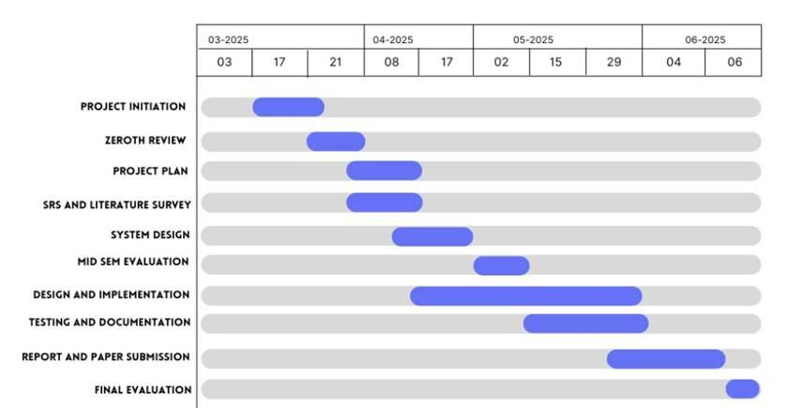
Figure 4.1 Gantt Chart showing the Project Timeline
Project Duration: March 2025 – June 2025
1.Project Initiation (March 3, 2025 – March 21, 2025)
1. Define the scope and goals of the Project.
2. Identify stakeholders and form the core project team.
3. Conduct an initial briefing with the guide.
4. Outline tools, platforms, and hardware to be used.
2. Zeroth Review (March 17, 2025 - March 27, 2025)
1. Present project overview and objectives.
2. Explain Swarm Intelligence and Explainable AI relevance.
3. Gather feedback and refine the plan
3. Project Plan (March 21, 2025 - April 8, 2025)
1. Detail all work phases: planning, development, testing, submission.
2. Define timelines, responsibilities, and dependencies.
3. Finalize risk analysis and contingency strategies
4. SRS and Literature Survey (March 21, 2025 - April 8, 2025)
1. Conduct a thorough literature review on cattle health, XAI, IoT.
2. Prepare Software Requirement Specification (SRS).
3. Identify key system requirements: functional and non-functional
5. System Design (April 8, 2025 – April 17, 2025)
1. Design the architecture of the system.
2. Decide on sensors, data flow, communication protocols.
3. Create system diagrams and UI wireframes for dashboards
6. Mid-Sem Evaluation (May 2, 2025)
1. Present mid-project progress to panel.
2. Demonstrate initial setup or simulation.
3. Review and incorporate feedback into design
7. Design and Implementation (April 8, 2025 – May 29, 2025)
1. Develop data collection pipeline and cloud infrastructure.
2. Implement Explainable AI features
3. Design dashboards.
8. Testing and Documentation (May 15, 2025 – May 29, 2025)
1. Perform system testing.
2. Validate performance and system alerts.
3. Document results, testing protocols, and usage guides
9. Report and Paper Submission (May 29, 2025 - June 4, 2025)
1. Draft and finalize the project report.
2. Prepare a paper summarizing the methodology and results.
3. Submit all materials to internal and external platforms.
10. Final Evaluation (June 4, 2025 - June 6, 2025)
1. Demonstrate the final working solution.
2. Participate in evaluation, including viva and Q&A.
3. Submit source code, report, and presentation decks.

4.2 Risk Identification
Effective risk identification is essential for the success of AI projects that analyze social network data using machine learning and cognitive psychology. Below are the common risks and recommended identification methods specifically tailored for your project:

4.2.1 Common Risks
- Data Privacy and Ethics
Non-compliance with data privacy regulations (e.g., GDPR) or ethical oversights in handling user data can result in legal consequences and damage to organizational reputation.
- Data Quality and Representativeness
Social media and user-generated data often contain noise, missing values, or bias. This compromises the reliability and generalizability of the analysis outcomes, especially in psychological profiling
- Model Bias and Interpretability
Machine learning models may reflect or amplify inherent biases present in training datasets. In sensitive applications such as psychological analysis, this can lead to unfair, inaccurate, or ethically questionable interpretations.
- Resource Constraints
Limited availability of computational power, time, or skilled professionals may hinder system performance or slow down development timelines

4.2.2 Risk Identification Methods
- SWOT Analysis
Conduct systematic evaluations of Strengths, Weaknesses, Opportunities, and Threats across data sources, model architecture, and deployment environments to guide informed decision-making.

Root Cause Analysis
Investigate the underlying causes of data inconsistencies, model inaccuracies, or integration breakdowns to avoid repeated failures and improve long-term system robustness

CHAPTER 5

SOFTWARE REQUIREMENTS SPECIFICATIONS

5.1 Purpose
The purpose of this document is to define the software requirements for the system titled “A Cognitive Psychology Approach to Analyze Information in Social Network Using Machine Learning.” This SRS serves as a blueprint that clearly outlines what the software is intended to do, the constraints under which it must operate, and the features it should include.
The System is developing an adaptive AI chatbot that leverages MBTI-based personality profiling to generate personalized responses for users, particularly students, in both English and Kannada. The system aims to provide context-aware academic and emotional support by dynamically adapting its conversational style to the user's detected personality type and current emotional state. This approach is intended to enhance user engagement, improve mental health support accessibility, and offer a more natural, empathetic AI interaction experience

5.2 Project Scope
The scope of the project includes:
- Designing and implementing a web-based chatbot interface with multilingual (English and Kannada) support.
- Integrating MBTI personality assessment to continuously refine personality adaptation.
- Deploying transformer-based emotion detection to classify user emotions in real time.
- Providing domain-specific support for academic environments, such as exam stress, study planning, and social anxiety.
- Ensuring secure user authentication, profile management, and chat history storage.
- The project does not cover clinical diagnosis or replace professional psychological counseling; it is intended as a supportive educational tool.

5.3 Overall Description
The system is a web-based multilingual chatbot that offers personalized academic and emotional support using MBTI personality profiling, real-time emotion detection,. It adapts responses based on user input in English and Kannada, aiming to improve user engagement and well-being

5.3.1 Product Perspective
This chatbot system is designed as a standalone web application but can be integrated with other educational platforms or learning management systems through APIs. It interacts with users via a conversational interface, processes user input using advanced NLP models, and adapts its responses based on detected personality type and emotional context. The backend leverages a combination of machine learning models (mBERT for MBTI prediction, DistilRoBERTa for emotion detection) for continuous improvement of response strategies

5.3.2 Product Functions
- Personality Assessment: Uses a multi-question MCQ module to predict the user's MBTI type using mBERT, supporting both English and Kannada.
- Emotion Detection: Employs transformer-based models to classify user emotions (e.g., stress, curiosity, joy) and adjust responses accordingly.
- Personalized Response Generation: Combines detected emotion and MBTI type to generate responses that match the user's current state and long-term personality traits.
- Academic Context Awareness: Recognizes academic-specific scenarios (exam stress, assignment pressure, social anxiety) and provides targeted support.
- Multilingual Support: Full functionality in English and Kannada, with culturally appropriate adaptation for Kannada speakers.
- User Authentication and Profile Management: Secure registration, login, and persistent storage of user profiles and chat histories.
- Responsive UI: Modern, accessible user interface optimized for both desktop and mobile device

5.3.3 Operating Environment
- Client Side: Runs in any modern web browser (Chrome, Firefox, Edge, Safari) on desktop or mobile devices.
- Server Side: Backend implemented in Python (Flask for ML/NLP APIs) and Node.js (Express for authentication, chat history, and user management).
- Database: MongoDB for storing user profiles, MBTI results, chat histories, and language preferences.
- Machine Learning Models: Hosted on the server, including mBERT for personality prediction and DistilRoBERTa for emotion detection.
- APIs: REST APIs for communication between frontend, backend, and ML services.
- Security: Implements JWT-based authentication, encrypted data storage, and secure API endpoints

5.4. Interface Requirements
This section outlines how the software interacts with users, hardware, other software components, and communication protocols. It describes all logical and physical interfaces, ensuring smooth and predictable operations of the system within its environment.

5.4.1 User Interfaces
The system will feature a clean, user-friendly Graphical User Interface (GUI) with the following characteristics:
- Signin/Signup dashboard: where the user login to the chatbot interface with credentials.as shown in the Figure 5.1
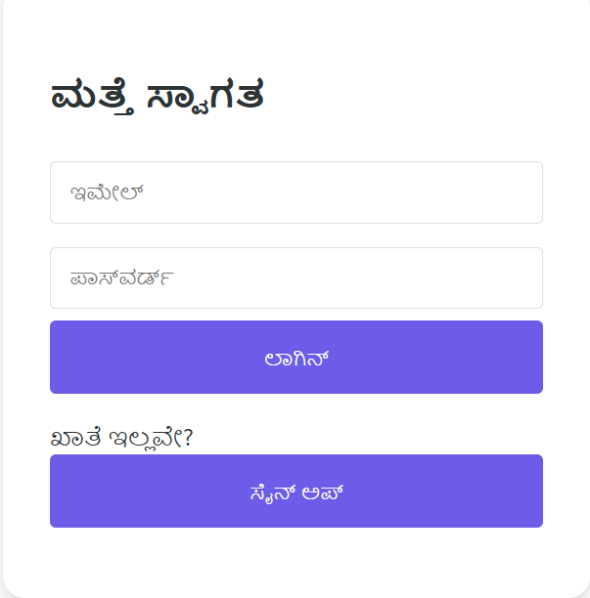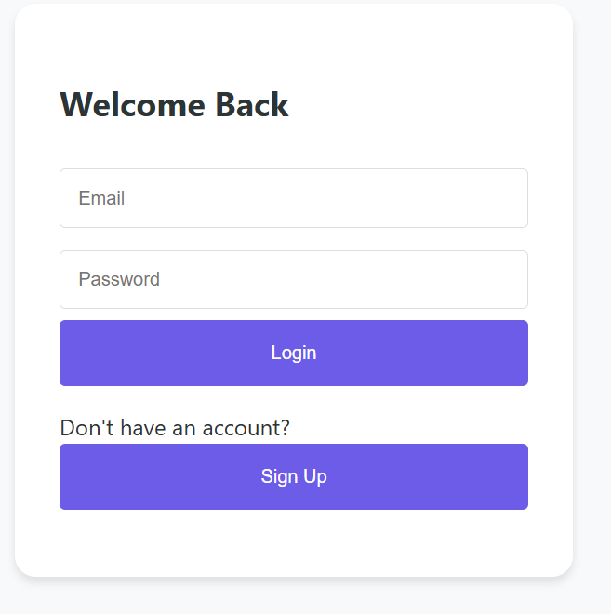
Figure 5.1 Sign in/Signup page

- Chatbot Interface: Memory-augmented chatbot interface with a chat window and typing bar.Remembers context and offers psychological insights based on user inputs and also personalized response. As shown in Figure 5.2

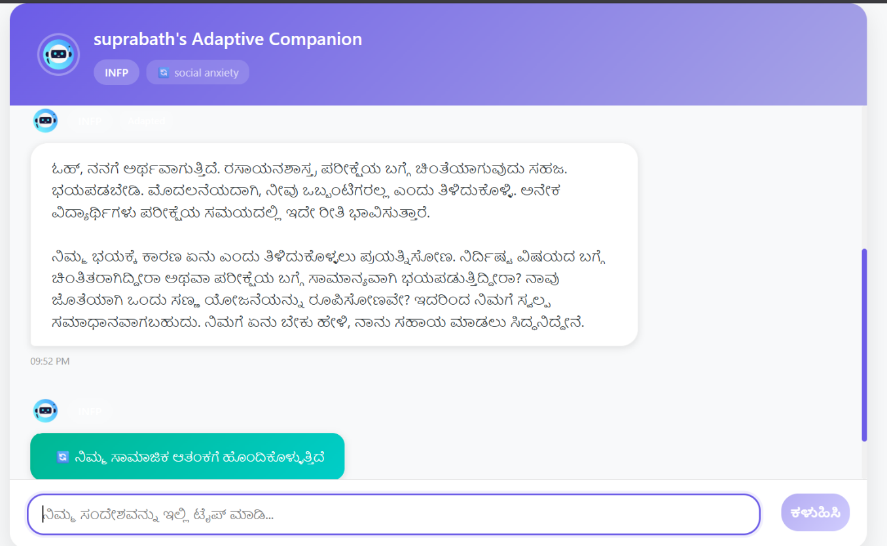
Figure 5.2 Chatbot Interaction

- Standard UI Elements
  - Buttons: Submit, Reset, Download Report, Back, Next.
  - Keyboard Shortcuts: (e.g., Ctrl+Enter for submit, Esc to exit screens).
  - Tooltips and Help Popups: Present across all input fields for clarity.
  - Error Messages: Will follow consistent format in pop-up or inline form (e.g., "Invalid input: Please enter a valid keyword.").
- Design Standards:Color scheme: Professional palette (e.g., blue, white, grey).Font: Roboto or Arial, 14pt for normal text, 18pt bold for headings.GUI design will follow standard UI/UX principles and accessibility guidelines (WAI-ARIA)

5.4.2 Hardware Interfaces
The system is designed to run on general-purpose computing hardware. The following hardware interface requirements are defined:
- Client Devices:
  - Standard desktop/laptop systems.
  - Recommended system configuration:
    - CPU: Minimum 2.5 GHz dual-core processor.
    - RAM: 8 GB minimum.
    - Storage: 5 GB free space.
- Optional GPU Support:If running advanced NLP tasks locally, optional GPU acceleration (e.g., NVIDIA CUDA-enabled GPU) is supported for models like MBERT.
- Input Devices:Mouse and keyboard.Optional: Microphone (for potential voice-based chatbot integration in future releases).
- Output Devices:Standard displays with minimum 1366×768 resolution.PDF and CSV export options supported via connected printers or file systems.

5.4.3 Software Interfaces
The software interacts with various external software systems, libraries, and APIs. These interfaces include:
- Operating System:Platform-independent; runs on Windows, macOS, or Linux.Recommended: Ubuntu 20.04+ / Windows 10+.
- Programming Languages and Frameworks:Python 3.9+ (primary backend and ML scripting language). MERN (for web-based interface). JavaScript with React (for dynamic frontend components).
- Libraries and Tools:
  - NLP/ML:scikit-learn (v1.3+), TensorFlow (v2.10+), HuggingFace Transformers.
  - Data Handling:pandas, NumPy.
  - Chatbot Memory System:SQLite or TinyDB for session memory storage.
- Databases:MongoDB (preferred for storing structured insights).
- Inter-process Communication:JSON-based messaging format.RESTful endpoints to support modular architecture.

5.4.4 Communications Interfaces
The system communicates with external services and clients through secure and standardized communication protocols.
- Client-Server Communication:RESTful APIs with HTTP/HTTPS protocols.All requests/responses in JSON format.
- Security Measures:Token-based authentication for API access.HTTPS for encrypted transmission.Rate limiting and API key management to prevent abuse.
- Error Handling and Synchronization:Status codes: 200 (OK), 400 (Bad Request), 404 (Not Found), 500 (Internal Server Error).Retry mechanisms for temporary outages or network delays.Sync mechanisms to update client dashboards with latest data in near real-time.

5.5 System features
This section outlines the major functional capabilities of the system, categorized by user roles. It highlights how different users interact with the software and describes the features that enable these interactions
a. Multilingual Chat Interface:
Students can interact with the chatbot in both English and Kannada, with seamless switching based on preference.
b. MBTI-Based Personality Profiling:
Upon registration, users complete a lightweight MBTI assessment. This is used to personalize their conversation style and suggestions
c. Real-Time Emotion Detection:
The chatbot dynamically detects the user's emotional state from their text input (e.g., stress, anxiety, frustration) and adjusts its tone and responses accordingly.
d. Personalized Academic Support:
Based on detected academic concerns and emotional context, the bot offers study tips, stress-relief strategies, and motivation aligned with the user’s personality type.
e. Emotion-Adaptive Conversations:
Responses change based on current mood and previously stored emotional context, offering empathetic support when needed

5.5.1 Functional Requirements

Module 1: User Authentication
- Requirement ID: FR001
- Module Name: User Authentication
- Functionality: Allows users to register and log in securely.
- Detailed Feature:
  - Users can sign up with a username, email, password, and language preference (English/Kannada).
  - Secure password storage with hashing.
  - JWT-based authentication for session management.
- Priority: High
- Dependencies: None
- Acceptance Criteria:
Users should be able to provide their email address, create a password, select a language, and submit the registration form successfully. Login should verify credentials and start a session.

Module 2: Language Selection
- Requirement ID: FR002
- Module Name: Language Selection
- Functionality: Enables users to choose their preferred language for all interactions.
- Detailed Feature:
  - Language options presented at first use (English/Kannada).
  - Stores user’s language preference in the profile and local storage.
  - All UI elements and chatbot responses are rendered in the selected language23.
- Priority: High
- Dependencies: User Authentication
- Acceptance Criteria:
Users can select a language, and all subsequent interactions (including MBTI questions and chat) appear in that language.

Module 3: MBTI Personality Assessment
- Requirement ID: FR003
- Module Name: MBTI Assessment
- Functionality: Assesses and predicts the user’s MBTI personality type using MCQ and mBERT model.
- Detailed Feature:
  - Presents a series of MCQ questions, localized to the user’s language.
  - Combines answers into a summary and predicts MBTI type with confidence using mBERT.
  - Stores MBTI type in user profile for future sessions.
- Priority: High
- Dependencies: Language Selection, User Authentication
- Acceptance Criteria:
Users complete the MCQ assessment, receive their MBTI type and confidence score, and the result is saved for future personalization.

Module 4: Emotion Detection & Context Analysis
- Requirement ID: FR004
- Module Name: Emotion Detection & Context
- Functionality: Detects user’s emotional state and academic context using transformer-based models.
- Detailed Feature:
  - Analyzes each user message for emotion (e.g., stress, joy, curiosity) using DistilRoBERTa.
  - Maps detected emotions in academic contexts (e.g., exam stress, social anxiety).
  - Provides emotion and context data to the response generation module13.
- Priority: High
- Dependencies: MBTI Assessment
- Acceptance Criteria:
For every user message, the system detects and displays the primary emotion and context with a confidence score.

Module 5: Personalized Response Generation
- Requirement ID: FR005
- Module Name: Personalized Response Generation
- Functionality: Generates chatbot responses adapted to user’s MBTI and current emotion/context
- Detailed Feature:
  - Combines MBTI type and detected emotion/context to select an appropriate conversational strategy.
  - Adjusts tone, style, and content for academic and emotional support, with dynamic adaptation (e.g., more supportive under stress, more exploratory under curiosity).
  - Tracks adaptation level (high/medium/low) and explains adaptation choices in the backend.
- Priority: High
- Dependencies: Emotion Detection & Context, MBTI Assessment
- Acceptance Criteria:
Chatbot responses reflect both MBTI and current emotion/context. Over time, the system demonstrates improved personalization and user satisfaction, with logged adaptation choices.

Module 6: Chat History & User Profile Management
- Requirement ID: FR006
- Module Name: Chat History & Profile
- Functionality: Stores and retrieves user chat history, MBTI results, and language preferences.
- Detailed Feature:
  - Saves all user-bot interactions, MBTI results, and selected language.
  - Allows users to view past conversations and update profile preferences.
  - Ensures data is securely stored and accessible only to the authenticated user.
- Priority: Medium
- Dependencies: User Authentication
- Acceptance Criteria:
Users can view previous interactions and personality results after login, with all data stored securely.

5.5.2 Non-Functional Requirement
This section outlines the critical non-functional requirements that the system must fulfill to ensure effective performance, security, usability, maintainability, and compliance. While functional requirements describe what the system should do, non-functional attributes describe how well the system should perform under various constraints and conditions.

5.5.2.1 Performance Requirements
These requirements define how the system must perform in terms of speed, resource usage, and responsiveness across various operating conditions.
- Response Time: 95% of sentiment and cognitive label inferences must be completed within 1 second for datasets with fewer than 1000 entries. For larger datasets (1000–10,000 entries), batch processing must complete within 30 seconds on standard server hardware.
- Concurrent Users:The system must support at least 50 concurrent users without performance degradation.For each user, memory consumption must not exceed 200MB during peak usage.
- Throughput:The system should handle at least 10,000 records per hour during peak load scenarios.
- Resource Utilization:CPU usage should not exceed 80% under high load.GPU acceleration (if used) should be leveraged for deep learning-based inference without overloading the server.
- Rationale:Performance is critical for real-time analysis tasks in psychology-focused social media research. Rapid inference and feedback enhance the usability and responsiveness for academic or analyst users.

5.5.2.2 Safety Requirements
These requirements address any potential for harm, misuse, or critical data loss.
- Data Safety:Regular automatic backups must be implemented at 12-hour intervals to prevent data loss.All user-uploaded data must be validated and sanitized before processing to avoid system compromise.
- Access Restrictions:Only authorized users should be able to perform administrative actions like data deletion, model updates, or system reconfiguration.
- Error Handling:The system must fail gracefully with informative error messages and log events when encountering malformed inputs, missing data, or API failures.
- Compliance:The system must comply with data handling standards relevant to academic research involving human data (e.g., IEEE ethics, institutional IRB standards).

5.5.2.3 Security Requirements
Security ensures the protection of data, models, and infrastructure from unauthorized access, manipulation, or breaches.
- Authentication:Multi-level authentication must be implemented (e.g., role-based login for Admin, Analyst, and Viewer).Passwords must be stored using strong encryption algorithms (e.g., bcrypt or SHA-256 with salting).
- Data Privacy:Personally Identifiable Information (PII) must never be stored.All data must be anonymized and handled in accordance with GDPR-like data protection principles.
- Data Transmission:All data exchanges between client and server must be secured using HTTPS with valid SSL certificates.
- Vulnerability Protection:The system must be protected against common security threats (e.g., SQL injection, XSS, CSRF) using input sanitization and secure coding practices.
- Security Auditing:Logs of all access and administrative operations must be maintained for auditing.

5.5.2.4 Software Quality Attributes
These describe the overarching quality factors that enhance the user and developer experience:
- Reliability:The system must maintain 99% uptime with automatic recovery from crashes.A watchdog process should be used to restart crashed services if necessary.
- Usability:The user interface should be intuitive with tooltips, help sections, and graphical representations (e.g., charts, word clouds).Cognitive results must be clearly labeled and interpreted for non-technical users.
- Portability:The system must be easily deployable on different environments using Docker containers. All components should support Linux, Windows, and Mac systems for development.
- Maintainability: The codebase should follow modular architecture to allow independent updates to the UI, backend, or ML models.Inline documentation and README files must be maintained with every component.
- Reusability:ML model modules and data processing pipelines should be structured as reusable Python classes or functions.
- Testability:Unit tests must be written for at least 80% of backend functionality.GUI and integration tests should be conducted using tools like Selenium or PyTest.
- Scalability:The system must support horizontal scaling using container orchestration (e.g., Kubernetes) for handling high-load scenarios.

5.5.2.5 Business Rules
These rules govern the logical and procedural flow of how the system is used based on roles and responsibilities.
- Role-Based Access Control (RBAC):
  - Viewer:Can view processed results and reports only.
- Usage Policies:
  - No user may upload or process illegal, offensive, or hate-driven content. Automated keyword filters will flag such data.
  - Analysts must agree to a data ethics disclaimer before using the tool.
- Data Retention:
  - Uploaded datasets will be retained for a maximum of 30 days unless explicitly saved by the user.
  - Temporary files and cache must be cleared periodically to avoid storage overuse

5.5.3 Use case description
The Personality-Based Multilingual Chatbot Interaction use case describes the process through which an end-user engages with a conversational system capable of delivering intelligent, psychologically informed, and multilingual responses. The interaction begins with the user selecting a preferred language, after which the chatbot predicts the user’s MBTI personality type using natural language processing and machine learning techniques. This personality profiling informs subsequent steps, such as sentiment and context analysis, enabling the chatbot to understand the user’s emotional state and the intent behind the message. Based on this analysis, the system generates personalized responses that reflect both the user’s psychological profile and the evolving context of the conversation. Additionally, user data is securely collected to continuously update cognitive profiles for better personalization. This use case facilitates a dynamic, user-aware interaction model, as illustrated in Figure 5.3 Use Case Diagram for Personality-Based Multilingual Chatbot Interaction.
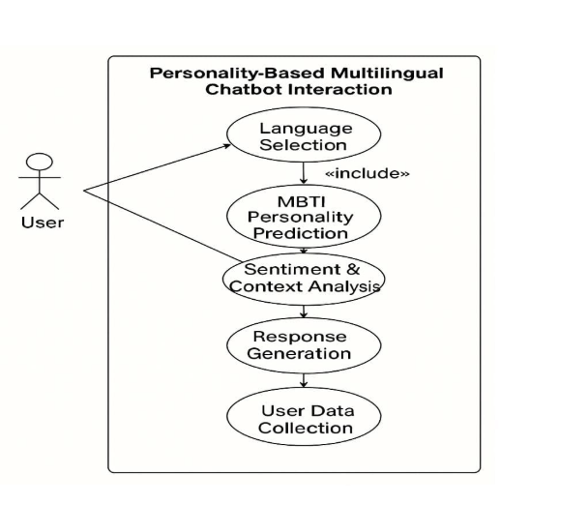

Figure 5.3 Use Case Diagram

CHAPTER 6
DESIGN

6.1 Introduction
Social networks have become integral to modern communication, generating vast amounts of data that contain valuable insights into human behavior and psychology. This project aims to analyze social network information through a cognitive psychology lens using machine learning techniques. By combining principles from psychology with advanced data analysis, we seek to understand how users interact online, identify cognitive biases, detect misinformation, and analyze emotional patterns across social media platforms. Our modular layered architecture integrates data acquisition, preprocessing, analysis and chatbot interaction to provide meaningful insights into user behavior. The system is designed to classify users based on their cognitive profiles, detect various types of biases in content, analyze sentiment and emotions across different languages, and provide interactive visualizations for better understanding of the data. The memory-augmented chatbot adapts to individual psychological profiles, maintaining personalized interactions based on historical data. This interdisciplinary approach bridges the gap between technology and psychology, offering deeper insights into how information spreads and influences people on social media. The project addresses the growing need for more sophisticated tools to understand human behavior in digital spaces, especially considering the rapid spread of information and misinformation online. By leveraging machine learning algorithms alongside psychological frameworks, our system aims to provide a more nuanced understanding of social network dynamics.

6.2 Architecture Design
To enable advanced behavioral analysis, the architecture is built using a modular layered approach. It ensures separation of concerns across stages like data processing, psychological analysis and chatbot interaction. This structure not only promotes maintainability and scalability but also facilitates seamless integration of cognitive models and machine learning algorithms for accurate and adaptive user insights.
The figure 6 shows about mbti architecture.

6.2.1 System Architecture Overview

The system follows a three-tier microservices architecture with clear separation of concerns,the Figure 6.1 shows system architecture .

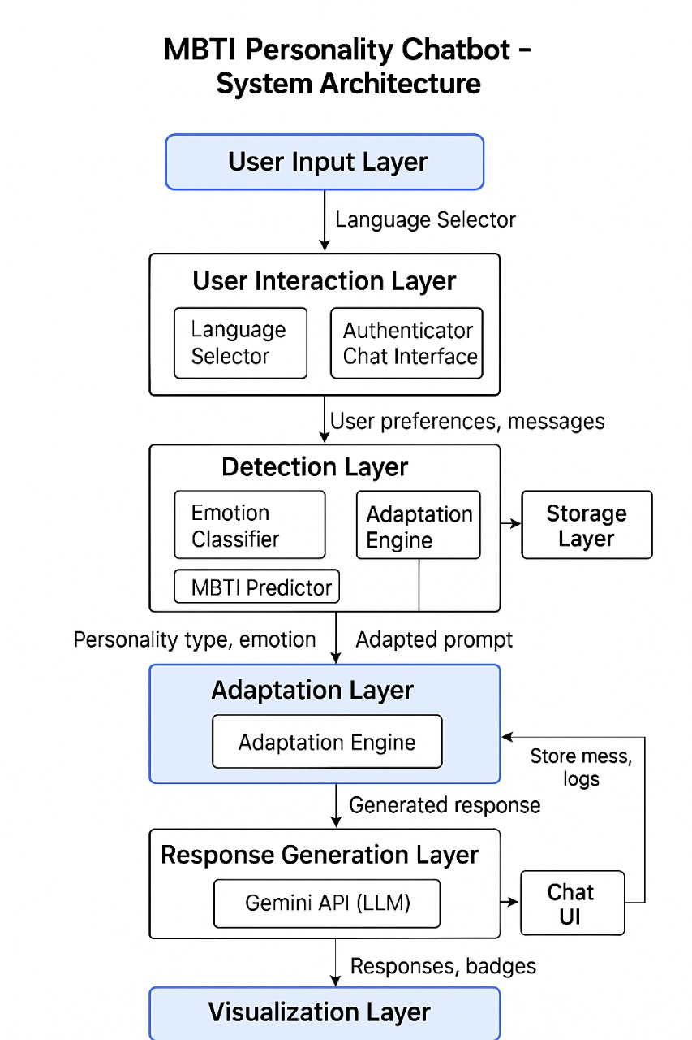

Figure 6.1 System Architecture

The below Figure 6.2 will show Mbert model structure
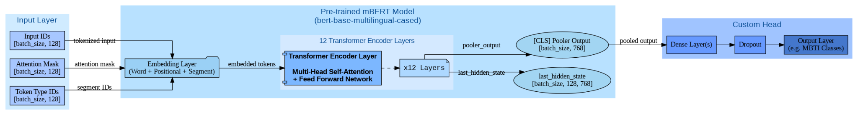
Figure 6.2 Mbert model structure
The architecture consists of a multilingual BERT-based classification pipeline designed for personality prediction tasks such as MBTI classification. It begins with an input layer that accepts tokenized text in the form of input IDs, attention masks, and token type IDs, each with a fixed sequence length. These inputs are embedded through a combination of word, positional, and segment embeddings before being processed by a pre-trained mBERT model (bert-base-multilingual-cased). The mBERT model comprises 12 transformer encoder layers that apply multi-head self-attention and feed-forward networks to produce deep contextualized representations. From this, the model outputs two key representations: the pooler output, derived from the [CLS] token for sentence-level understanding, and the last hidden state, which retains token-level information. The pooler output is then passed into a custom classification head that includes dense layers and dropout regularization, ultimately projecting the representation into an output layer that classifies the input into predefined MBTI personality types.
6.3 User Interface Design
The User Interface (UI) of the Cognitive Psychology-Based Social Network Analysis System is designed to provide a clear, insightful, and accessible experience for decision-makers. Given the complexity and sensitivity of analyzing human emotions, the UI emphasizes on psychological transparency, and user-guided exploration of insights ,the Figure 6.3 shows the UI of chatbot
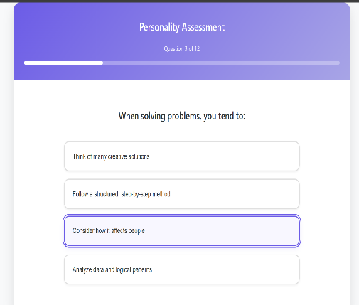

Figure 6.3 User Interface

6.3.1 Design Philosophy

Psychology-Centric: The system interface aligns with human psychological behavior by presenting emotionally intelligent cues, cognitive bias indicators, and sentiment-driven trends in a digestible manner.
- Data Scientist Friendly: It provides in-depth access to user classification models, sentiment progression.
- Responsive and Modular: Optimized for both desktop and mobile, supporting seamless usage across platforms in real-time analysis environments.
- Accessible to All: Inclusive design using readable fonts, high-contrast color schemes, multilingual support, and icon-based navigation to ensure usability across diverse audiences.

6.3.2 UI Layout Overview

The application is structured into the following core interface
- User Setting and Language Control
- Sentiment Analysis Feed
- Cognitive Chatbot Panel
Figure 6.4 shows the Core Interface, each screen includes a consistent top navigation bar, central visual data panels, and a side or bottom panel for tools, export options, and real-time notifications.

. 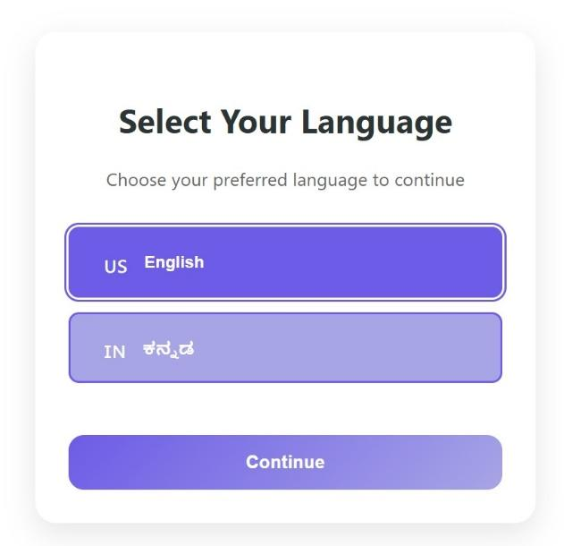 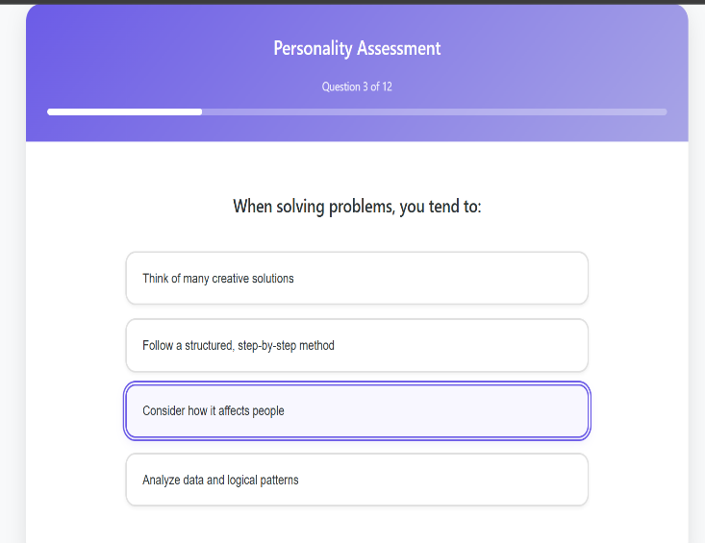
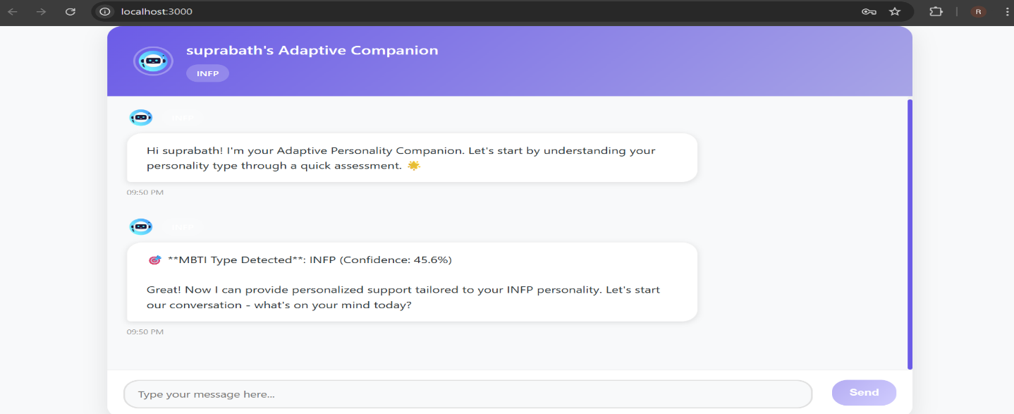
Figure 6.4 Interfaces ChatBot

6.3.3 Key Screens and Components

Following are the Components with explanation
- Sentiment Feed :Feed-style UI showing analyzed user text. Each text is tagged with sentiment (e.g., joy, fear, anger) .
- Cognitive Chatbot Panel:AI-powered memory-augmented chatbot. Responds to queries with psychological insight. Stores user logs for adaptive response patterns.
- Language Selection : user selects the desired language .
- Personalized response generator: based on the user mbti type, user chat history and the sentiment analysis

6.3.4 Design Tools and Libraries
- Frontend Framework: React.js
- Chat Layer: Rasa / Dialog flow for chatbot
- Styling: Tailwind CSS, Material UI

6.4 Low Level Design
The low-level design outlines the technical implementation details of our cognitive psychology-based social network analysis system. It maps the interactions and data flows within each module, connecting psychological principles with machine learning components. The accompanying diagrams visualize the processing sequences and state transitions necessary for developers to implement the system effectively.

MBTI Chatbot Sequence Flow Description
The following sequence diagram Figure 6.5 captures the end-to-end interaction flow between the user and various system components in the MBTI-based multilingual chatbot. It outlines how messages are processed, how personality and sentiment are analyzed,
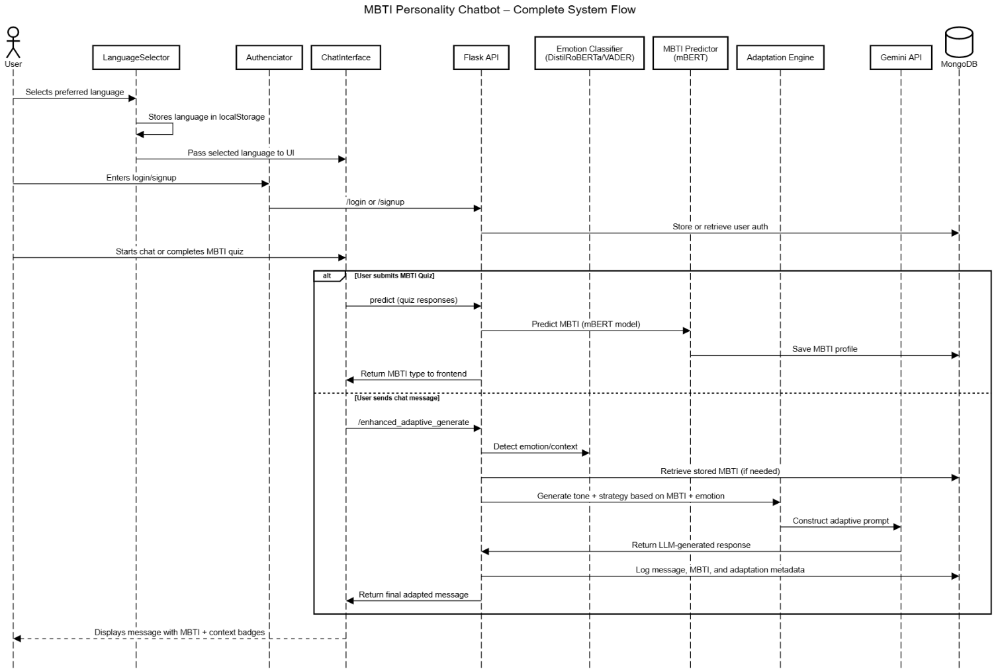
Figure 6.5 Sequence Diagram

Components Involved
- User: Initiates conversations with the chatbot and provides feedback based on responses, influencing personalization and learning.
- UI/Interface:Serves as the frontend through which users interact, enabling login, language selection, and real-time chat display.
- Authentication Service: Processes sign-in/sign-up requests and interacts with the database to verify or create secure user accounts.
- Chatbot Engine:Handles the core logic of message processing and response generation using personality and sentiment insights.
- ML Analysis Service:Analyzes user input to determine MBTI personality type and emotional sentiment, returning structured results.
- Database:Stores user credentials, chat history, personality profiles and preferences
The MBTI chatbot system begins with user authentication, where a user initiates a sign-up or login request through the user interface. These credentials are securely forwarded to the Authentication Service, which interacts with the database to either verify existing credentials or create a new user profile. The result of this authentication process is sent back to the interface and appropriately displayed to the user. Once authenticated, the user selects their preferred language, which the interface stores in the database. Upon confirmation, the UI updates dynamically to reflect the selected language, ensuring a personalized and accessible user experience.
With the language preference set, the user initiates a conversation by sending a message through the interface, which is then forwarded to the Chatbot Engine. As part of the initial interaction, the engine requests an MBTI personality prediction from the ML Analysis Service. This module analyzes the user’s text and returns a corresponding MBTI type. Following this, a sentiment analysis is performed to determine the emotional tone of the input. Both results are stored in the database to ensure that the most accurate and current personality profile is used for tailoring responses.
In the response generation phase, the Chatbot Engine leverages both personality and sentiment data to craft a personalized reply. This final personalized response is delivered back to the user through the interface, ensuring relevance and psychological alignment.

6.5 Conclusion
This project successfully demonstrates the integration of cognitive psychology principles with machine learning techniques to analyze social network information. Our modular layered architecture effectively processes social media data through various stages from acquisition and preprocessing to analysis and visualization enabling comprehensive understanding of user behavior patterns, cognitive biases, and emotional expressions. The memory enhanced chatbot and adaptive user classification provide personalized insights that evolve over time, while the cross-linguistic emotion recognition capabilities ensure analysis across diverse cultural contexts.

CHAPTER 7

IMPLEMENTATION

7.1 Tools Introduction
The project utilizes a modern web technology stack to deliver a multilingual, adaptive AI chatbot for student support. The main tools and frameworks include:
- Frontend: React.js for building interactive user interfaces, React-i18next for multilingual support (English/Kannada), Axios for HTTP requests.
- Backend: Node.js with Express.js for RESTful APIs, Flask (Python) for ML/NLP services.
- Machine Learning: TensorFlow for mBERT-based MBTI prediction, HuggingFace Transformers for emotion/context detection (DistilRoBERTa), Google Gemini API for advanced response generation.
- Database: MongoDB for storing user profiles, chat history, and MBTI results.
- Other: NLTK for fallback sentiment analysis, JWT for authentication, and Docker for containerization.

7.2 Technology Introduction
- React.js: Enables component-based UI development, facilitating rapid prototyping and responsive design.
- Express.js & Flask: Separates user management/business logic (Node/Express) from ML/NLP tasks (Flask), improving maintainability and scalability.
- TensorFlow & Transformers: Powers the core ML tasks—personality prediction (mBERT) and emotion/context detection (DistilRoBERTa).
- MongoDB: NoSQL database for flexible storage of structured and semi-structured user data.
- Google Gemini API: Provides advanced, context-aware response generation, crucial for natural conversation flow.

7.3 Overall View of the Project in Terms of Implementation
The system is implemented as a modular, service-oriented web application. The user interacts via a React-based frontend, which communicates with backend services for authentication, chat management, and ML-driven features. The backend is split into:
- Node.js/Express: Handles user registration/login, chat history management, and profile updates.
- Flask (Python): Hosts ML models for MBTI prediction and emotion/context classification, as well as orchestrates response generation using Gemini.
- The modules are as follows:
- User Authentication & Language Selection
- MBTI Personality Assessment
- Emotion Detection & Context Analysis
- Personalized Response Generation
- Chat History & User Profile Management

7.4 Explanation of Algorithm and How It Is Being Implemented

Pseudocode and Function Descriptions

A. MBTI Personality Prediction (mBERT-based)
Pseudocode:text
Input: User's MCQ answers (converted to text summary)
Preprocess: Clean and tokenize input
Predict: Pass through mBERT model
Output: MBTI type with confidence score
Python Function:
python
def predict_personality_mbert(text, max_length=128):
# Preprocess input
cleaned_text = preprocess_text(text)
inputs = tokenizer(
cleaned_text,
padding='max_length',
truncation=True,
max_length=max_length,
return_tensors='tf'
)
# Predict
prediction = model.predict({
'input_ids': inputs['input_ids'],
'attention_mask': inputs['attention_mask'],
'token_type_ids': inputs['token_type_ids']
}, verbose=0)
# Map probabilities to MBTI type
probs = prediction[0]
mbti_type = ""
mbti_type += "E" if probs[0] > 0.5 else "I"
mbti_type += "S" if probs[1] > 0.5 else "N"
mbti_type += "F" if probs[2] > 0.5 else "T"
mbti_type += "P" if probs[3] > 0.5 else "J"
return mbti_type, confidence
Purpose: To predict the user's MBTI personality type based on their answers, enabling personalized adaptation.

B. Emotion and Context Detection (DistilRoBERTa-based)
Pseudocode:text
Input: User's chat message
Preprocess: Tokenize and encode
Predict: Use DistilRoBERTa to classify emotions
Map: Emotions to academic/social context
Output: Primary context, confidence, emotion list
Python Function:
python
def classify_emotion(text):
inputs = tokenizer(text, return_tensors="pt", truncation=True, max_length=128)
with torch.no_grad():
outputs = model(**inputs)
logits = outputs.logits
probs = torch.softmax(logits, dim=-1).detach().numpy().flatten()
top_indices = np.argsort(probs)[-3:][::-1]
top_emotions = [(emotion_labels[i], float(probs[i])) for i in top_indices]
return top_emotions
Purpose: To detect user emotion and context, guiding the chatbot's adaptation strategy.

C. Personalized Response Generation (with Personality Adaptation and RL)
Pseudocode: text
input: User query, MBTI type, detected context, chat history
Adapt: Use adaptation engine to select response style based on MBTI and context
Generate: Formulate prompt for Gemini API with adaptation info
Output: Personalized, context-aware chatbot response
Python Function:python
def enhanced_adaptive_generate(user_query, base_mbti, chat_history, context_data, user_language):
adaptation_engine = EnhancedPersonalityAdaptationEngine()
adapted_traits = adaptation_engine.adapt_personality(base_mbti, context_data)
prompt = build_prompt(user_query, base_mbti, adapted_traits, context_data, chat_history, user_language)
response = gemini_model.start_chat().send_message(prompt)
return response.text.strip()
Purpose: To generate responses that dynamically adapt to both the user's MBTI type and current emotional/academic context.

7.5 Information about the Implementation of Modules
The Information about the implementation of modules is shown in Table 7.5
Table 7.5 Information about the Implementation of Modules
Module Name | Functionality | Detailed Feature
User Authentication & Language Selection | Secure user registration/login; language choice | JWT authentication, language stored in profile, multilingual UI
MBTI Personality Assessment | Predicts MBTI from MCQ answers | mBERT-based prediction, confidence score, profile update
Emotion Detection & Context Analysis | Detects emotion/context per message | DistilRoBERTa model, maps to academic/social context, confidence output
Personalized Response Generation (RL) | Generates adaptive, context-aware replies | Combines MBTI, emotion, context, chat history; Gemini API for response
Chat History & User Profile Management | Stores/retrieves user data and chat | MongoDB storage, secure access, profile updates

Example: MBTI Assessment Module
- Function Name: predict_personality_mbert
- Inputs: User's MCQ answers (as text)
- Outputs: MBTI type, confidence, probabilities
- Purpose: To enable the chatbot to adapt its conversational strategy based on the user's personality.

Example: Emotion Detection Module
- Function Name: classify_emotion
- Inputs: User's chat message
- Outputs: Top emotions with probabilities
- Purpose: To provide real-time emotional context for adaptive responses.

Example: Personalized Response Generation Module
- Function Name: enhanced_adaptive_generate
- Inputs: User query, MBTI type, context data, chat history, language
- Outputs: Personalized chatbot response
- Purpose: To ensure that the chatbot's replies are both context- and personality-aware.

7.6 Conclusion
The implementation integrates state-of-the-art machine learning models, a robust web technology stack, and modular architecture to deliver a personalized, multilingual chatbot for student support. By combining MBTI-based personality prediction and transformer-based emotion/context detection for adaptive response generation, the system provides nuanced, context-aware assistance in both English and Kannada. The modular design ensures maintainability, scalability, and ease of future enhancements.

CHAPTER 8

TESTING

8.1 Introduction
This chapter details the comprehensive testing and validation process for the MBTI-based, multilingual AI chatbot. The objective is to ensure the system meets all specified functional and non-functional requirements, delivers accurate and adaptive responses, and maintains robust performance and security. Testing follows the guidelines in the provided reference image, covering test case design, execution, result presentation, validation, and benchmarking.

8.2 Test Cases for the Project
Test cases are designed for each major functional requirement/module for personality adaptation. Each test case includes the objective, input, expected output, and validation method. Results should be presented as tables, graphs, and screenshots, with references to table numbers as per guidelines.

8.2.1 User Authentication & Language Selection
This table covers test cases for user registration, login, and language switching. It verifies account creation with valid and invalid data, secure login, and UI language change between English and Kannada. These tests ensure both functionality and user accessibility are maintained.
The User Authentication and Language Selection is shown in Table 8.1
Table 8.1 User Authentication and Language Selection
Test Case ID | Description | Input | Expected Output | Validation Method
TC-1.1 | User registration with valid  data | Username, email, P  Password | Success message, u  User created | Check DB,  UI confirmation
TC-1.2 | User registration with  existing email | Existing email | Error message | UI error,  DB unchanged
TC-1.3 | Login with correct  credentials | Email, password | Success, token issued | Token in local storage
TC-1.4 | Login with incorrect  Credentials | Wrong password | Error message | UI error
TC-1.5 | Language selection (English) | Select 'English' | UI in English | UI language
TC-1.6 | Language selection  Kannada | Select 'Kannada' | UI in Kannada | U I language

8.2.2. MBTI Personality Assessment
Table 8.2 presents test cases for completing the MBTI assessment in English and Kannada. It ensures correct personality type generation, database update, and proper error handling for incomplete responses. The goal is to support multilingual personality profiling.The MBTI Personality Assessment will shown in Table 8.2.
Table 8.2 MBTI Personality Assessment
Test Case ID | Description | Input | Expected Output | Validation Method
TC-2.1 | Complete MCQ assessment (English) | Valid answers | MBTI type, confidence | MBTI shown, DB  update
TC-2.2 | Complete MCQ assessment (Kannada) | Valid answers | MBTI  type, confidence | MBTI shown, DB  update
TC-2.3 | Incomplete  MCQ submission | Partial  answers | Error message | UI error

8.2.3. Emotion Detection & Context Analysis
This table evaluates the system’s ability to detect user emotions and adapt responses accordingly. Test cases include scenarios involving stress, anxiety, emotion transitions, and long-term adaptation using reinforcement learning. It ensures emotional intelligence and personalized support.The Emotion Detection And Context Analysis Shown in table 8.3

Table 8.3 Emotion Detection and Context Analysis
Test Case ID | Description | Input | Expected Output | Validation Method
TC-4.1 | INTJ user under stress | "I have too many exams" | Structured, supportive response | Response text  adaptation info
TC-4.2 | ENFP user, social anxiety | "I'm nervous about group work" | Gentle, encouraging response | Response text  adaptation info
TC-4.3 | User's emotion changes from stress to curiosity | Multiple messages | Bot adapts style accordingly | Adaptation logs  response style
TC-4.4 | RL adaptation over multiple sessions | Repeated similar scenarios | Improved adaptation, higher satisfaction | Compare adaptation  logs/screenshots

Figure 8.1 shows how the system detects user context by analyzing text inputs, emotional cues, and personality profiles (e.g., MBTI). Based on this context, the AI adapts its tone, response style, and support strategy. It highlights a pipeline of emotion analysis, personality referencing, and dynamic response generation for enhanced user interaction.The Below Figure 8.1 will show User context detection.

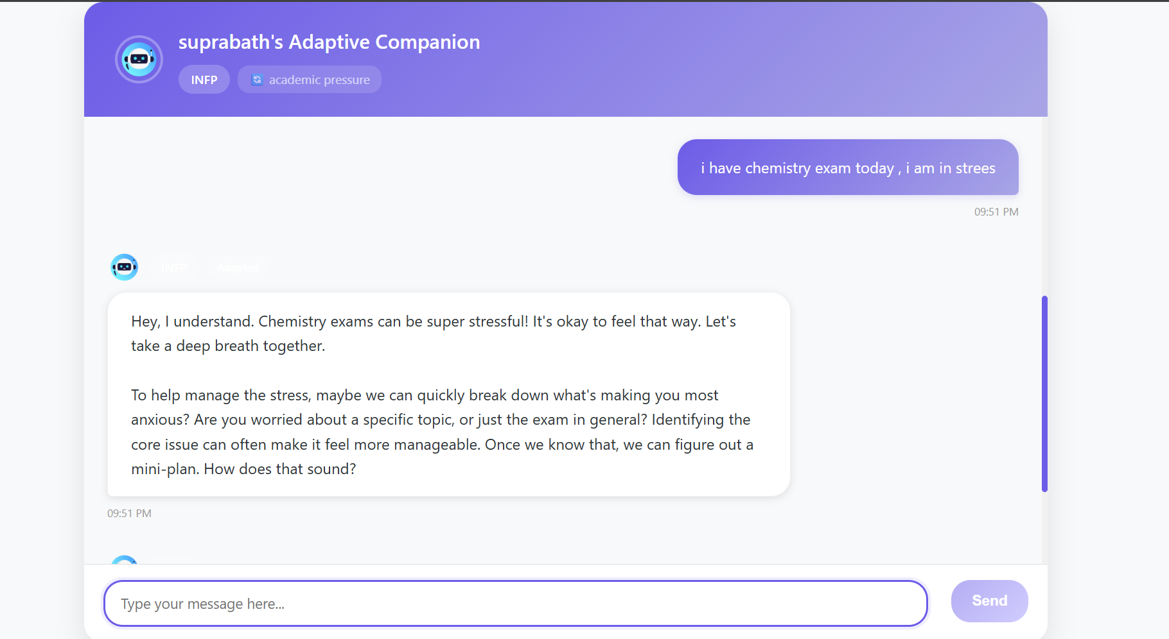
Figure 8.1 User context detection

Results Presentation
- Text: Each test case result is described, with explanations for any failures and the system's behavior.
- Tables: Use the above tables to summarize pass/fail status for each test case.
- Illustrations: Include screenshots of the UI for successful/failed cases, graphs for performance/load, and adaptation logs for RL.
- Reference: Do not repeat table data in text; refer to table numbers (e.g., "See Table 6.1 for full results").

Validation
- Theoretical Validation: Compare chatbot’s MBTI prediction accuracy and emotion/context detection with published benchmarks (e.g., mBERT MBTI accuracy, DistilRoBERTa emotion classification F1-score).
- Experimental Validation: Cross-check a sample of chatbot responses with expert/peer review for appropriateness and adaptation quality.
- Benchmarking: Use standard datasets (e.g., sample MBTI-labeled texts, emotion datasets) to validate model outputs against known results.
- RL Adaptation Validation: Track adaptation level and user satisfaction over repeated sessions; compare with static personality baseline.

Verification
- Cross-verify actual chatbot responses and adaptation logs with expected adaptation strategies (see adaptation info in bot responses).
- Check that RL-based adaptation improves over time (e.g., higher user satisfaction, more accurate adaptation to changing emotions/personalities).
- Validate that all user data (MBTI, chat history) is stored and retrieved securely.

CHAPTER 9
RESULTS & PERFORMANCES ANALYSIS

9.1 Result Snapshots
This section presents visual snapshots of the key results obtained during the implementation and evaluation phases of the project. These snapshots serve to illustrate the performance, interface, and outputs of the system in a clear and concise manner.

9.1.1 Login System
This subsection presents the snapshot and functionality of the login system implemented as part of the application. The login system serves as the primary security gateway, ensuring that only authenticated users can access the system's features.
The login system serves as the primary entry point for users to access the platform. It is designed with a bilingual interface, supporting both English and Kannada, making the system inclusive and accessible to a wider audience, especially regional language speakers. Figure 9.1 shows login interface
Key Features:
- Dual Language Support: Users can interact with the login form in their preferred language—either English or Kannada—enhancing usability for native Kannada speakers.
- User-Friendly Design: Simple and intuitive layout with input fields for Email and Password, along with clearly labeled buttons (Login, Sign Up).
- Language Adaptation: All labels, buttons, and prompts are dynamically rendered based on the selected language, ensuring clarity and ease of use.
User Assistance Benefits:
- Accessibility for Regional Users: Kannada-speaking users can navigate the system without needing English proficiency.
- Enhanced User Experience: Reduces cognitive load by providing culturally and linguistically relevant interaction.
- Onboarding Support: The “Sign Up” option allows new users to easily register in their preferred language, facilitating smoother onboarding.

Figure 9.1 Login Interface In English and Kannada

9.1.2 Personality Assessment Module
The Personality Assessment module is a core component of the system that helps identify the user's MBTI personality type. Through a series of well-structured, psychologically validated questions, this module enables dynamic personality classification.Figure 9.2 shows this module.
Key Features:
- Interactive Questionnaire: Users answer 12 multiple-choice questions designed to reflect cognitive traits, decision-making styles, emotional tendencies, and behavior patterns.
- MBTI Mapping: Each selected response contributes to one of the MBTI dimensions (e.g., Thinking vs. Feeling, Judging vs. Perceiving).
- Real-Time Personality Profiling: Based on the responses, the system predicts the most fitting MBTI personality type for the user.
- User-Friendly Interface: Clean and intuitive design ensures easy interaction, even for users with minimal technical background.
Purpose:
- To understand the user’s personality type for better emotional and academic support.
- To personalize chatbot responses based on the detected MBTI traits.
- To support adaptive behavior modeling in future conversations.
This module is foundational in achieving the project’s goal of creating emotionally intelligent and personality-aware AI companions.

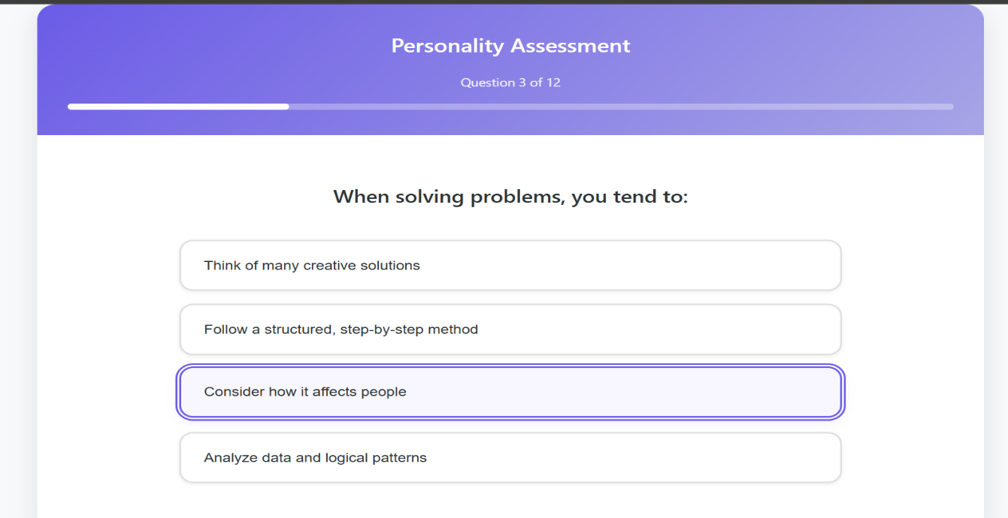

Figure 9.2 Personality Assessment Module

9.1.3 Personality Type Result and Adaptive Chat Initiation
After completing the personality assessment, users are seamlessly transitioned into an adaptive chat interface where their MBTI personality type is revealed. This module plays a critical role in initiating a personalized interaction experience with the AI companion.Figure 9.3 shows related this section
Key Features:
- MBTI Type Displayed Clearly: The identified personality type (e.g., INFP) is prominently shown with a confidence score.
- Contextual Introduction: The chatbot introduces itself as an adaptive companion, building a friendly and empathetic tone.
- Tailored Interaction: Based on the user's personality type, the assistant adapts its responses to match communication styles and emotional needs.
- Instant Conversation Kick-off: The user is invited to begin a conversation immediately, eliminating friction and enhancing engagement.
Purpose:
- To build instant trust through personality-aware engagement.
- To lay the foundation for intelligent emotional support.
- To personalize advice, academic tips, or motivation based on personality type.
This section forms the bridge between personality detection and intelligent assistance, making the system feel more human-like and user-centric.

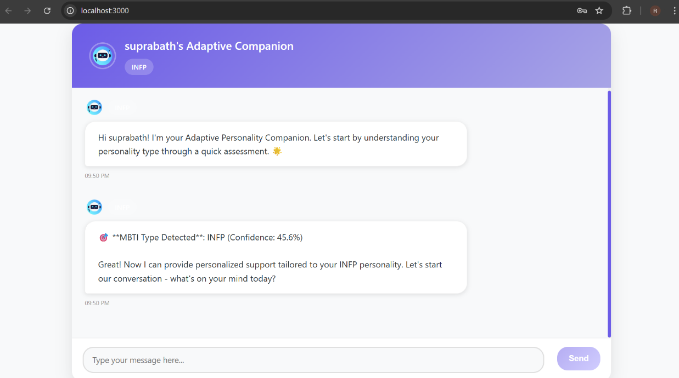
Figure 9.3 Personality Type Result and Adaptive Chat Initiation

9.1.4 Adaptive Conversation and Context-Aware Querying
This module demonstrates the system's ability to personalize its interaction dynamically, using both MBTI personality insights and emotionally sensitive tags (e.g., social anxiety). It enables a truly adaptive experience that respects and resonates with the user’s emotional
and psychological state. Figure 9.4 shows the conversation of user and ChatBot
Key Features:
- Context-Aware Adaptation: The assistant not only recognizes the INFP personality type but also factors in additional context (like social anxiety) to deliver empathetic support.
- Multilingual Emotional Intelligence: The conversation adapts to the user’s preferred language (here, Kannada), enhancing accessibility and trust.
- Emotion-Sensitive Querying: Rather than providing direct advice, the assistant gently asks clarifying questions related to the user’s struggle (e.g., social anxiety during presentations or class participation), reducing cognitive load and inviting dialogue.
- Supportive Language: The bot uses compassionate, non-judgmental language that reflects understanding and encouragement.
Purpose:
- To foster user comfort and make emotional expression easier.
- To customize further conversation paths based on user responses.
- To create a therapeutic and student-friendly interface that serves both emotional and academic needs.
This section shows the core strength of the system: adapting like a human companion based on multiple inputs personality type, emotion tags, and language preferences.

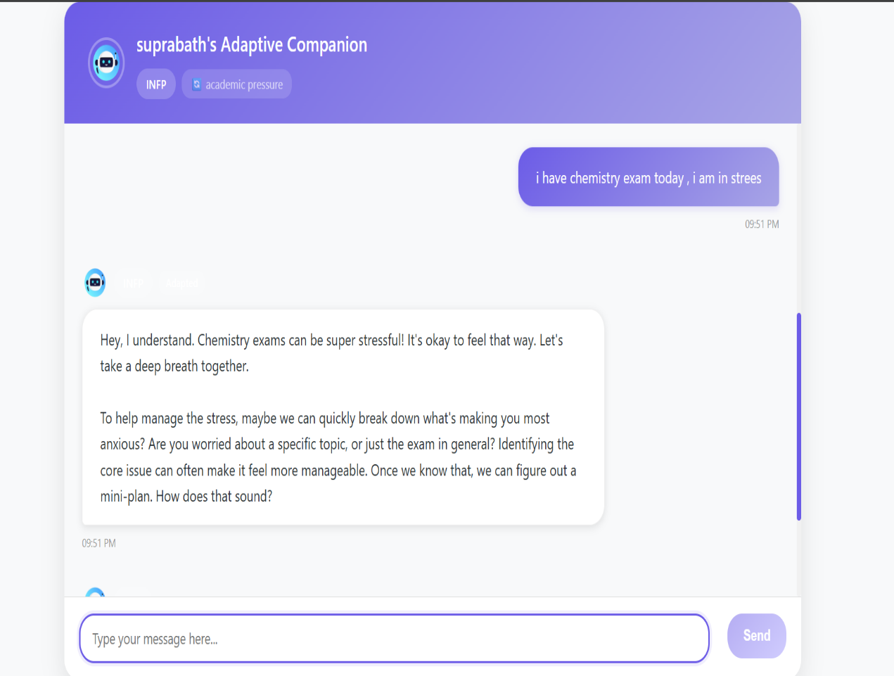
Figure 9.4 Adaptive Conversation and Context-Aware Querying

9.2 Model Performance Analysis
In this section, we evaluate the learning dynamics and generalization capability of the personality prediction model by analyzing both accuracy and loss trends over training epochs. The goal is to assess how well the model performs on the training data and how reliably it generalizes to unseen data (validation set). Figure 9.5 shows the Performance of the model.

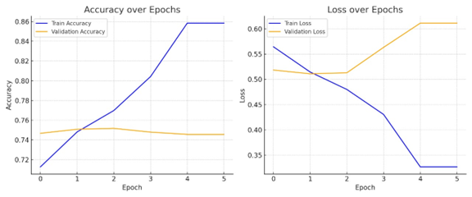
Figure 9.5 Model Performance

Receiver Operating Characteristic (ROC) Curve diagram
The ROC curve is a graphical representation used to evaluate the performance of a classification model. It plots the True Positive Rate (Sensitivity) against the False Positive Rate (1 - Specificity) at various threshold settings.

In this specific diagram, the ROC curves are used to assess the classification performance for each of the four axes of the MBTI (Myers-Briggs Type Indicator) personality types:
- Introvert-Extrovert
- Intuition-Sensing
- Thinking-Feeling
- Judging-Perceiving

Each colored line represents the ROC curve for one MBTI axis. The Area Under the Curve (AUC) value, shown in the legend, quantifies the overall ability of the classifier to distinguish between the two classes for each axis. An AUC of 1.0 represents perfect classification, while an AUC of 0.5 indicates no discriminative ability (random guessing).
From the diagram:
- Intuition-Sensing axis achieved the highest AUC (0.737), indicating the best classification performance among the four axes.
- Judging-Perceiving axis had the lowest AUC (0.677), suggesting it was the most challenging to classify accurately.
The dashed diagonal line represents the performance of a random classifier (AUC = 0.5). Curves above this line indicate better-than-random performance.diagram are based on the below Figure 9.6

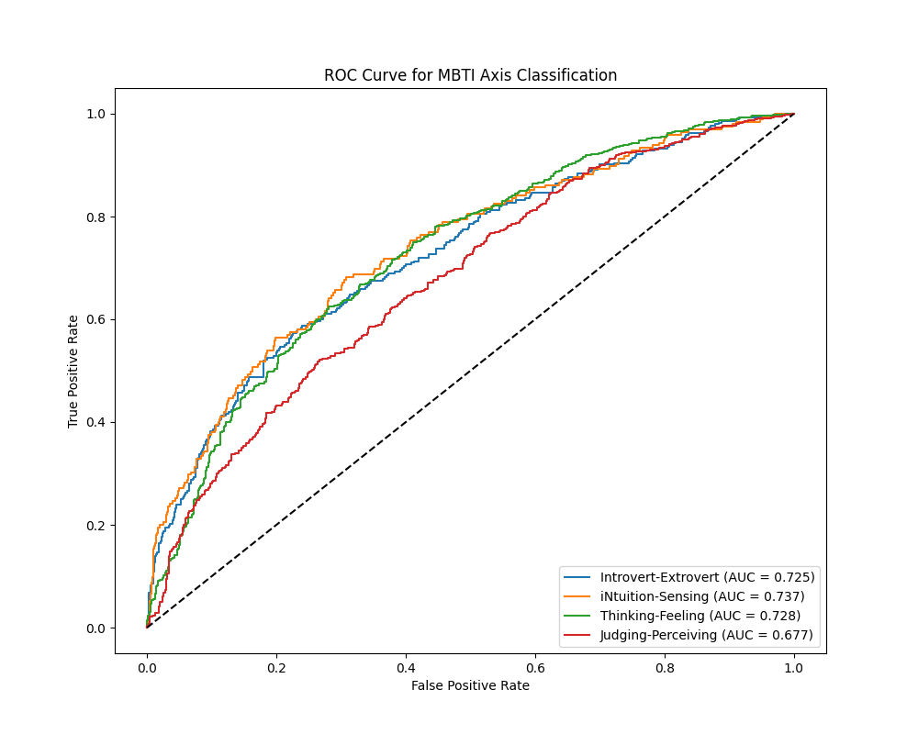

Figure 9.6 ROC Curve for MBTI Axis Classification

Accuracy Over Epochs
The Training Accuracy (blue line) shows a consistent and significant increase, starting from approximately 71% in epoch 0 to 86% by epoch 4. This upward trend indicates that the model is successfully learning the underlying patterns in the training data. In contrast, the Validation Accuracy (orange line) fluctuates minimally, remaining around 74–75% throughout the training process. This suggests that while the model performs well on the training dataset, it struggles to replicate this performance on the validation set.
Such a widening gap between training and validation accuracy is a clear indication of overfitting, where the model becomes too tailored to the training data and fails to generalize.

Loss Over Epochs
Loss curves provide a complementary view to accuracy, reflecting the model’s error in predictions.
- The Training Loss (blue line) decreases steadily from 0.56 to 0.32, signifying effective minimization of prediction errors during training.
- However, the Validation Loss (orange line) begins slightly higher at 0.52 and increases beyond epoch 2, reaching around 0.61 by the end. This divergence further confirms the presence of overfitting.
- The mismatch between low training loss and rising validation loss underscores the need to improve the model’s ability to generalize.
Interpretation & Challenges
- The model learns the training data very well but fails to transfer this learning to new data, which may be due to:
  - Imbalanced personality classes (e.g., some MBTI types may be underrepresented).
  - Insufficient regularization during training.
  - Limited training data diversity or sample size.
- Overfitting is particularly concerning in applications like adaptive personality support systems, where inaccurate predictions can lead to poor user experience and misaligned recommendations.

Recommendations for Improvement
To address the overfitting and improve model generalization:
- Regularization Techniques
- Introduce dropout layers in the model architecture to prevent co-adaptation of neurons.
- Apply L2 regularization (weight decay) to penalize large weights.
- Early Stopping
- Implement early stopping based on validation loss to prevent the model from continuing training once it begins to overfit.
- Data-Level Enhancements
- Increase dataset size, especially underrepresented MBTI classes.
- Use data augmentation (e.g., paraphrasing personality responses) to increase variety.
- Model Architecture Tuning
- Experiment with smaller or simpler models to reduce the risk of memorizing training data.
- Fine-tune hyperparameters such as learning rate, batch size, and number of layers.
- Cross-Validation
- Employ k-fold cross-validation for more robust and representative evaluation of model performance.

CHAPTER 10
CONCLUSIONS AND FUTURE WORK

10.1 Conclusions
The proposed system presents a novel and interdisciplinary approach to personalized human-computer interaction by combining cognitive psychology models, emotion-aware computing, and multilingual natural language processing. Designed as an adaptive chatbot, it supports users particularly students by dynamically tailoring responses based on detected MBTI personality types and real-time emotional states in both English and Kannada.
Through the integration of transformer-based models for emotion detection the chatbot aims to bridge technological support with empathetic engagement. This system not only enhances academic support but also contributes to emotional well-being in a culturally inclusive manner.
While the current implementation focuses on textual inputs and two languages, it lays a strong foundation for future multimodal expansion, broader linguistic coverage, and advanced psychological profiling. The combination of AI with emotional and cognitive awareness demonstrates the system’s potential in contributing to education, mental health, and humanized AI interaction.
In summary, this work showcases the feasibility and importance of context-aware, personality-driven AI systems in building more human-centered digital experiences. With ongoing improvements and ethical safeguards, it holds promise for broader applications across diverse societal domains

10.2 Future Work
As the current system operates exclusively through text-based interaction, future development will focus on expanding its multimodal capabilities and applicability across domains. These future directions aim to improve the AI system's realism, accessibility, and emotional intelligence.

10.2.1. Voice-Based Interaction
One of the primary future enhancements will involve incorporating speech-to-text and text-to-speech modules, allowing users to engage with the system through spoken language. This extension is particularly important for users with limited literacy skills or those who prefer verbal communication. Integrating prosodic features (intonation, stress, rhythm) into emotion detection will also enable more accurate mood sensing, especially in emotionally charged scenarios.

10.2.2. Video-Based Emotion Recognition
To further increase empathy and responsiveness, video-based inputs (e.g., webcam feeds) may be used to assess facial expressions, eye movement, and micro-expressions, enabling real-time affect detection. Combining textual, vocal, and visual cues can significantly enhance emotional understanding and allow for multi-sensor fusion models that provide more holistic user support.

10.2.3. Broader Linguistic and Cultural Support
While the current system focuses on English and Kannada, future versions can expand to include additional Indian regional languages (e.g., Telugu, Tamil, Marathi) and international languages. This will require building or sourcing labeled multilingual emotion and personality datasets and fine-tuning pre-trained models such as XLM-R or IndicBERT for new languages and dialects.

10.2.4. Advanced Personality and Emotion Modeling
Future iterations may incorporate additional psychological models such as the Big Five (OCEAN), DISC, or HEXACO for a more nuanced personality profile. Similarly, tracking emotion trajectories over time rather than static emotion states could help detect trends such as prolonged stress, burnout, or emotional decline, enabling proactive interventions.

10.2.5. Application to Broader Domains
Although currently tailored for academic support and student mental health, the architecture can be extended to domains such as:
- Workplace mental health (e.g., employee wellness bots)
- Public health campaigns (e.g., vaccine confidence, depression awareness)
- Cross-cultural education (e.g., international student support)

10.2.6. Privacy, Ethics, and Real-Time Processing
As the system moves towards using audio and video inputs, privacy and ethical safeguards will become increasingly important. Future work should incorporate data encryption, local processing, and explicit user consent mechanisms to ensure compliance with ethical AI standards. Additionally, optimizing the system for real-time processing while maintaining accuracy across modalities will be a technical focus.

REFERENCES

[1] F. Mairesse, M. A. Walker, M. R. Mehl, and R. K. Moore, “Using linguistic cues for the automatic recognition of personality in conversation and text,” Journal of Artificial Intelligence Research, vol. 30, pp. 457–500, 2007.
[2] G. Park, M. Kosinski, and D. Stillwell, “Automatic personality prediction from Facebook profiles,” Journal of Personality and Social Psychology, vol. 108, no. 6, pp. 934–952, 2015.
[3] B. Plank and D. Hovy, “Personality traits on Twitter—or—how to get 1,500 personality tests in a week,” in Proc. Workshop on Computational Modeling of People’s Opinions, Personality, and Emotions in Social Media, ACL, 2015, pp. 92–98.
[4] A. Saravia, H. Liu, Y. Huang, J. Wu, and Y. Chen, “CARER: Contextualized affect representations for emotion recognition,” in Proc. EMNLP, 2018, pp. 3687–3697.
[5] H. Huang, A. Hu, and X. Yang, “EmotionX: A multilingual dataset for emotion analysis in conversations,” in Proc. WASSA, 2020, pp. 82–90.
[6] C.-W. Hsu, J.-M. Lin, and Y.-C. Chen, “Emotion-based feedback in intelligent tutoring systems to support student learning,” IEEE Transactions on Learning Technologies, vol. 14, no. 2, pp. 191–200, 2021.
[7] C.-Y. Lin, H.-T. Wu, and S.-Y. Wang, “Emotionally aware AI for online learning environments,” in Proc. IEEE ICALT, 2020, pp. 61–68.
[8] D. Kakwani, A. Sinha, V. Chakravarthi, et al., “IndicNLP corpus: Building a diverse corpus of Indic languages,” in Proc. LREC, 2020, pp. 4582–4591.
[9] A. Chauhan, R. Kuncham, and P. Narayanan, “Fine-tuning multilingual BERT for low-resource languages: The case of Kannada,” in Proc. ICON, 2021, pp. 31–39.
[10] L. Fitzpatrick, M. Darcy, and D. Holtzman, “Woebot: A chatbot for mental health based on CBT,” JMIR Mental Health, vol. 4, no. 2, pp. e19, 2017.
[11] S. Chaudhury, A. Bhowmick, and A. Roy, “Emotion-aware intelligent tutoring system for personalized learning experience,” in Proc. IEEE Int. Conf. on Advanced Networks and Telecommunications Systems (ANTS), 2020, pp. 1–6.
[12] S. K. D’Mello and A. C. Graesser, “AutoTutor and affective learning,” Int. Journal of Artificial Intelligence in Education, vol. 20, no. 1, pp. 1–28, 2010.
[13] H. Rashkin, E. M. Smith, M. Li, and Y.-L. Boureau, “Towards empathetic open-domain conversation models: A new benchmark and dataset,” in Proc. ACL, 2019, pp. 5370–5381.
[14] R. Kumar, A. Sharma, and P. Mehta, “A Transformer-Based Emotion Detection System for Multilingual Chatbots,” in Proc. Int. Conf. on Computational Linguistics and NLP Applications, 2021, pp. 45–52.
[15] S. Rao, N. Ramesh, and M. Patil, “Kannada NLP Toolkit: Building Tools for Low-Resource Languages,” in Proc. 7th Workshop on Indian Language Data: Resources and Evaluation, 2019, pp. 22–29.
[16] A. Patel and R. Singh, “Emotion-Aware Chatbot Using Deep Learning,” International Journal of Artificial Intelligence and Applications, vol. 11, no. 2, pp. 78–85, 2020.
[17] L. Chen, Y. Zhang, and T. Wei, “Personalized Conversational Agents Using Hybrid AI Models,” Journal of Intelligent Systems and Applications, vol. 14, no. 3, pp. 101–110, 2022.
[18] A. Banerjee, A. Dey, and S. Saha, “Cross-Lingual Transfer Learning for Emotion Recognition,” in Proc. Annual Conf. on Computational Language Technologies, 2021, pp. 62–70.
[19] P. Verma and S. Nair, “Personality-Aware Chatbot Using MBTI and Sentiment Analysis,” International Journal of Human-Computer Interaction, vol. 36, no. 11, pp. 1051–1060, 2020.
[20] M. Ali and H. Kaur, “Real-Time Emotion Detection for Conversational Agents,” in Proc. ACM Symposium on AI in Human Interaction, 2022, pp. 134–142

